FNS50417 Diploma of Payroll Services

Module 1.2 assignment
Instructions:
- This assignment contains multiple Assessment Activities
- Please complete the Declaration of Authenticity at the bottom of this page
- Save this assignment (e.g. on your desktop)
- To complete the assignment, read the instructions for each question carefully.
- You may be required to refer to your learning materials or other sources to complete this assessment.
- You are required to type all your responses in the spaces provided
- Once you have completed all parts of the assignment and saved it, login to the Monarch Institute LMS to submit your assignment for grading
- To submit your assignment click on the file “Submit Dip. Payroll Module 1.2 Assignment” in the Module 1 section of your course and upload your assignment file.
    - Please be sure to click “Continue” after clicking “submit”. This ensures your assessor receives notification of your submission – very important!

Declaration of Understanding and Authenticity *
I have read and understood the assessment instructions provided to me in the Learning Management System.

I certify that the attached material is my original work. No other person’s work has been used without due acknowledgement. I understand that the work submitted may be reproduced and/or communicated for the purpose
of detecting plagiarism.

Student Name*: Date:
* I understand that by typing my name or inserting a digital signature into this box that I agree and am bound by the above student declaration.

Important assessment information
Aims of this assessment
This assessment focuses on processing financial transactions and extracting interim and final financial reports.
Marking and feedback
This assignment contains multiple Assessment Activities each containing specific instructions.
This particular assessment forms part of your overall assessment for the following unit(s) of competency:
- FNSACC311 Process financial transactions and extract interim reports
Grading for this assessment will be deemed “competent” or “not-yet-competent” in line with specified educational standards under the Australian Qualifications Framework.
What does “competent” mean?
These answers contain relevant and accurate information in response to the question/s with limited serious errors in fact or application. If incorrect information is contained in an answer, it must be fundamentally outweighed by the accurate information provided. This will be assessed against a marking guide provided to assessors for their determination.
What does “not-yet-competent” mean?
This occurs when an assessment does not meet the marking guide standards provided to assessors. These answers either do not address the question specifically, or are wrong from a legislative perspective, or are incorrectly applied. Answers that omit to provide a response to any significant issue (where multiple issues must be addressed in a question) may also be deemed not-yet-competent. Answers that have faulty reasoning, a poor standard of expression or include plagiarism may also be deemed not-yet-competent. Please note, additional information regarding Monarch’s plagiarism policy is contained in the Student Information Guide which can be found here: http://www.monarch.edu.au/student-info/

What happens if you are deemed not-yet-competent?
In the event you do not achieve competency by your assessor on this assessment, you will be given one more opportunity to re-submit the assessment after consultation with your Trainer/ Assessor. You will know your assessment is deemed ‘not-yet-competent’ if your grade book in the Monarch LMS says “NYC” after you have received an email from your assessor advising your assessment has been graded.
Important: It is your responsibility to ensure your assessment resubmission addresses all areas deemed unsatisfactory by your assessor. Please note, if you are still unsuccessful in meeting competency after resubmitting your assessment, you will be required to repeat those units.
In the event that you have concerns about the assessment decision then you can refer to our Complaints & Appeals process also contained within the Student Information Guide.
Expectations from your assessor when answering different types of assessment questions
Knowledge based questions:
A knowledge based question requires you to clearly identify and cover the key subject matter areas raised in the question in full as part of the response.
Performance based questions:
A performance based question requires you to clearly demonstrate your ability to complete certain tasks, that is, to perform these tasks.

Good luck
Finally, good luck with your learning and assessments and remember your trainers are here to assist you

Assessment Activities
Short Answer and Worked Answer Questions
FNSACC311 Process financial transactions and extract interim reports

Activity instructions to candidates
- This is an open book assessment activity.
- You are required to read this assessment and answer all questions that follow.
- Please type your answers in the spaces provided.
- Please ensure you have read “Important assessment information” at the front of this assessment
- Estimated time for completion of this assessment activity: approximately 3 hours

The following questions are based on the material in the textbook “Accounting Principles” by Anne Collins & Andrew Duncan, 13th Edition, Book 1 (January 2018). Book 1 contains Chapters 1- 13.

The following questions are based on the material in Chapter 1:

1a. Explain the concept of the ‘accounting entity’.

1b. List and describe the 6 legislative requirements that must be complied with by accountants and bookkeepers.

1c. Define the accounting function. What 3 accounting practices are carried out under the accounting function?

The following questions are based on the material in Chapter 2:
2. For the following accounts, show the Account Type (Asset, Liability, Owner’s Equity, Revenue or Expense) and the Report (Balance Sheet or Income Statement) to which it belongs:

 | Account Type | Report
Inventory
Mortgage
Accounts Receivable
Wages
Sales
Cost of Goods Sold
Advertising
Accounts Payable
Furniture and Fittings
Fees Received
Capital
Telephone Expense
Drawings
Electricity Expense
Loan
Motor Vehicle
Cleaning Fees paid
Interest Received

The following questions are based on the material in Chapter 3:

3a. Surveying Consultants provides surveying services and are registered for GST in accordance with the legislative and regulatory requirements relating to financial transactions for businesses of their size.
Their services are mainly surveying services: revenue accounts are set up as Surveying Fees (A/C 410) and Other Fees (A/C 411).

The following cash receipt documents are for the first week in August. The firm banks daily.
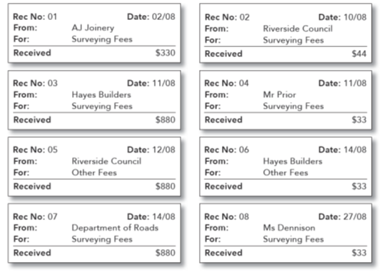

Required:

- What type of documents are these?

- What information should be included in such a document, and has this been done?

- Please record the information from these documents, per the firm’s organisational procedures, in the Cash Receipts Journal for August using the following template.

Cash Receipts Journal
Date | Receipt No. | Details | A/C  No. | Survey Fees | Other Fees | GST Collected | Amount Banked
 |  |  | N/A
 |  |  | N/A
 |  |  | N/A
 |  |  | N/A
 |  |  | N/A
 |  |  | N/A
 |  |  | N/A
 |  |  | N/A
TOTAL |  |  | N/A

3bi). List 3 key details you need to look for on a cheque to ensure the cheque is valid?

3bii). What checks does the EFTPOS system perform before processing an EFTPOS transaction?

3biii). From the information provided below, you are required to complete a receipt. Chemco Pty Ltd received a cheque from AC Cleaning on 1 June 2018 for the amount of $240 being payment for their account.
Chemco Pty Ltd Date ……………………………
RECEIPT
Received from: ………………………………………………………………………….
The sum of: ………………………………………………………………………………. $........................... Cash/Cheque
For: ………………………………………………………….……………………………….. …………………….………………………….
Signature
3c. Describe the banking procedures that could be used for depositing batch cheques and cash using a deposit slip. Include the details that should be included in the deposit form.

3d. Identify some industry-accepted security and safety precautions when transporting cash from a workplace to a bank.

3e. What documentation is provided to a business as ‘proof of lodgement’ for banking monies? How would you file these?
Tip: Think about whether you would file these with other records/documents and if in any specific order.

The following questions are based on the material in Chapter 4:
4a. According to its organisational procedures, enter the transactions of Salt Works into the Cash Payments Journal and the totals at 17 May.

May 03 | Chq 52 | Wages | 730 (no GST)
May 05 | Chq 53 | Telephone | 320 plus GST
May 09 | EFT | Rent | 820 plus GST
May 12 | EFT | Drawings | 120 (no GST)
May 12 | EFT | Inventory | 1,800 plus GST
May 16 | EFT | Inventory | 1,400 plus GST
May 17 | Chq 54 | Wages | 730 (no GST)

Cash Payments Journal
Date | Chq # or EFT | Details | Account No. | Purchases of Stock | Wages | Rent | Other Payment | GST  Paid | Total Paid
 |  |  | N/A
 |  |  | N/A
 |  |  | N/A
 |  |  | N/A
 |  |  | N/A
 |  |  | N/A
 |  |  | N/A
TOTAL

4b. Please list the controls / procedures that you could adopt in a business for the handling of Electronic payments, Cheques and Cash.

The following questions are based on the material in Chapter 5:
5(a) Required: For the following transactions, complete the Transaction Analysis Chart.
(The first transaction has been completed for you.)
Date | Transaction | Account Name | Account Type | $ Increase + or  $ Decrease - | DR or CR
01/6 | Initial capital paid into business bank account $35,000 | Bank  Capital | A  OE | +$35,000  +$35,000 | DR  CR
02/6 | Received money for a long term loan $100,000
03/6 | Paid business insurance premium $700 + $70 GST + $40 stamp duty (no GST).
04/6 | Paid cash for stationery $165 including GST
05/6 | Interest received on bank account $25 (GST does not apply)
06/6 | Service revenues earned in cash amounted to $2,000 + $200 GST
07/6 | Commission revenue received $1200 + $120 GST
08/6 | Paid cash for a vehicle $16,000 + $1,600 GST
09/6 | Drawings $1,000
10/6 | Paid $20,000 off the loan

Also required: Using the templates provided:

(b) Prepare General Journal entries for the transactions.
(c) Post the General Journal entries to the ledgers and include ‘DR’ or ‘CR’ to each running Balance for each ledger account.
(d) Prepare a Trial Balance as at 10 June.

(5b) General Journal GJ
Date | Particulars | Folio | Debit | Credit
 |  | N/A
 |  | N/A
 | Owner’s Contribution | N/A
 |  | N/A
 |  | N/A
 | Received long term loan | N/A
 |  | N/A
 |  | N/A
 |  | N/A
 | Paid insurance (expense) | N/A
 |  | N/A
 |  | N/A
 |  | N/A
 | Purchased stationery | N/A
 |  | N/A
 |  | N/A
 | Interest Received | N/A
 |  | N/A
 |  | N/A
 |  | N/A
 | Received Service Revenue | N/A
 |  | N/A
 |  | N/A
 |  | N/A
 | Received Commission Revenue | N/A
 |  | N/A
 |  | N/A
 |  | N/A
 | Purchased Motor Vehicle | N/A
 |  | N/A
 |  | N/A
 | Owners Drawings | N/A
 |  | N/A
 |  | N/A
 | Repayment on Loan | N/A
5(c) Consistent with industry codes of practice Ledger Accounts should include ‘DR’ or ‘CR’ to each running Balance for each ledger account.
Bank (ASSET)
Date | Details | Folio | Debit | Credit | Balance
 |  | N/A
 |  | N/A
 |  | N/A
 |  | N/A
 |  | N/A
 |  | N/A
 |  | N/A
 |  | N/A
 |  | N/A
 |  | N/A

GST Paid (ASSET)
N/A
N/A
N/A

Vehicle (ASSET)
N/A

GST Collected (LIABILITY)
N/A
N/A

Loan (LIABILITY)
N/A
N/A

Capital (EQUITY)
N/A

Drawings (EQUITY)
N/A

Service Revenue (REVENUE)
 | Date | Details | Folio |  | Debit | Credit | Balance
 |  |  | N/A

Commission Revenue (REVENUE)
N/A

Interest Revenue (REVENUE)
N/A

Insurance (EXPENSE)
N/A

Stationery (EXPENSE)
N/A

5(d) Trial Balance
(5d) Trial Balance
 | Debit | Credit
Bank
GST Paid
Vehicle
GST Collected
Loan
Capital
Drawings
Service Revenue
Commission Revenue
Interest Revenue
Insurance
Stationery
TOTAL

5(e) If a trial balance does not balance, what steps would you take to ensure that it balances? If the trial balance balances, does that mean it is fully correct, and why?

5(f) Describe the concept of double entry accounting.

The following questions are based on the material in Chapter 6:
6a. T. Rade operates a petty cash system per its organisational procedures. Vouchers are checked and processed by the Petty Cashier and recorded in the Petty Cash Book.
From the following information for T. Rade:
(a) prepare and balance the Petty Cash Book.
(b) prepare the General Journal entries for:
(i) Establishment of the petty cash fund, and
(ii) Reimbursement of the fund.

01/7 The Petty Cashier received cheque 4233 for $100 to establish the fund.

In their organisational policy and procedure documents T. Rade specify that each expense is to be recorded on a separate voucher.

During the following week the Petty Cashier checked and paid the following amounts (GST inclusive), with each expense being on a separate voucher (starting at Voucher No. 1):
• 01/7 Tea & coffee $17.60 (GST Free),
• 01/7 taxi fare $7.70
• 02/7 Courier $11.00,
• 02/7 stationery $4.40
• 04/7 Biscuits $9.35,
• 04/7 taxi fare $9.90
• 06/7 Courier $5.50,
• 06/7 stationery $3.30
• 07/7 Office cleaning $11.00

The fund was reimbursed on July 8 (cheque 4275).
(a) Petty Cash Book - T . Rade
Cash Received | Date | Particulars | Voucher | Payments | Courier | Amenities | Stationery | Travel | Sundries | GST
 | Jul 1 | Advance
 |  |  | 1
 |  |  | 2
 | Jul 2 |  | 3
 |  |  | 4
 | Jul 4 |  | 5
 |  |  | 6
 | Jul 6 |  | 7
 |  |  | 8
 | Jul 7 |  | 9
 |  | Sub-Total |  | $ | $ | $ | $ | $ | $ | $
 |  | Bal. c/d |  | $
$100.00 |  |  |  | $100.00
$ |  | Bal. b/d
$ | Jul 8 | Reimbrsmt.

(b) General Journal – T. Rade
Date | Particulars | Debit | Credit
 | Petty Cash advance
 | Reimbursement of Petty Cash

6c. Small business, in particular those that are owner-operated, often have less formal ways of dealing with petty cash expenses. Instead of using a cash imprest system, list 2 alternative methods that could be used to deal with petty cash expenses which would still maintain the integrity of the relationship of the business’ financial systems. Why might a business review and update the way they treat petty cash expenses?

The following questions are based on the material in Chapter 7:
7. Below are selected transactions from the general journal of Brian Smith Catering for the month of March. These journals are in line with its policies and procedures and have been approved by the Finance Accountant.
General Journal - Brian Smith Catering
Date | Particulars | Folio | Debit | Credit
March 01 | Catering Supplies  GST Paid  Accounts Payable - Andrea  Credit purchase of catering stock | 715  125  210.01 | 600  60 | 660
20 | Catering Supplies  GST Paid  Accounts Payable – Dave  Credit purchase of catering stock | 715  125  210.03 | 300  30 | 330
27 | Accounts Payable – Andrea  Bank  Payment of account | 210.01  100 | 660 | 660
30 | Telephone  GST Paid  Accounts Payable – Telstra  Telephone account received | 765  125  210.04 | 100  10 | 110
31 | Accounts Payable – Office Shop  Bank  Payment of account | 210.02  100 | 88 | 88

Required:
(a) In line with its policies and procedures, post from the general journal to the general ledger and to the individual creditor accounts in the accounts payable subsidiary ledger. The opening balances have been entered for you.

(b) Prepare a schedule of accounts payable as at 31 March.
(7a) General Ledger - Brian Smith Catering
Bank 100
Date |  | Details |  | Folio |  | Debit | Credit | Balance
01/03 |  | Balance |  |  |  |  |  | 10,000 DR
GST Paid 125
 | Accounts Payable Control 210
 | Date |  | Details |  | Folio | Debit | Credit | Balance
 | 01/03 |  | Balance |  | N/A |  |  | 88 CR
 |  |  |  |  | N/A
 |  |  |  |  | N/A
 |  |  |  |  | N/A
 |  |  |  |  | N/A
 |  |  |  |  | N/A
 | Telephone 765
 |  |  |  |  | N/A
 | Catering Supplies 715
 |  |  |  |  | N/A
 |  |  |  |  | N/A

Payables Subsidiary Ledger - Brian Smith Catering
Date | Details | Folio | Debit | Credit | Balance
Andrea 210.01
 |  | N/A
 |  | N/A
Office Shop 210.02
01/03 | Balance | N/A |  |  | 88 CR
 |  | N/A
Dave 210.03
 |  | N/A
 |  | N/A
Telstra 210.04
 |  | N/A
 |  | N/A

(7b) Schedule of Accounts Payable Amounts
Supplier Name: | $
Total (must equal balance as per Accounts Payable Control Account)

8. Paymore Landscapers supplies you with the following information for October.
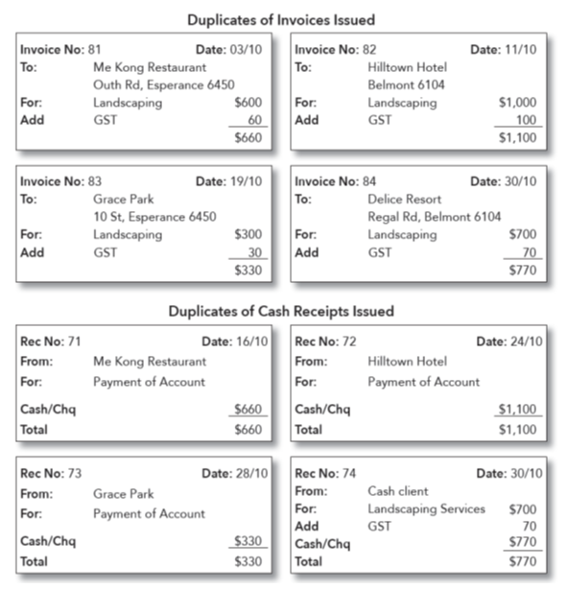
Required:
(a) Enter the above transactions into the General Journal.
(b) Post to the General Ledger and to the individual debtor accounts in the Receivables Subsidiary Ledger.
(c) Prepare a schedule of Accounts Receivable as at 31 October.

(a) General Journal - Paymore Landscapers
Date | Particulars | Folio | Debit | Credit
 |  | N/A
 |  | N/A
 |  | N/A
 | Credit Sales Invoice 81 | N/A
 |  | N/A
 |  | N/A
 |  | N/A
 | Credit Sales Invoice 82 | N/A
 |  | N/A
 |  | N/A
 | Receipt 71 | N/A
 |  | N/A
 |  | N/A
 |  | N/A
 | Credit Sales Invoice 83 | N/A
 |  | N/A
 |  | N/A
 | Receipt 72 | N/A
 |  | N/A
 |  | N/A
 | Receipt 73 | N/A
 |  | N/A
 |  | N/A
 |  | N/A
 | Credit Sales Invoice 84 | N/A
 |  | N/A
 |  | N/A
 |  | N/A
 | Cash Sales - Receipt 74 | N/A

(b) Paymore Landscapers Ledger
Bank 100
Date | Details | Folio | Debit | Credit | Balance
 |  | N/A
 |  | N/A
 |  | N/A
 |  | N/A
Accounts Receivable Control 110
 |  | N/A
 |  | N/A
 |  | N/A
 |  | N/A
 |  | N/A
 |  | N/A
 |  | N/A
GST Collected 230
 |  | N/A
 |  | N/A
 |  | N/A
 |  | N/A
 |  | N/A
Service Revenue 400
 |  | N/A
 |  | N/A
 |  | N/A
 |  | N/A
 |  | N/A

Paymore Landscapers – Receivables Subsidiary Ledger
Me Kong Restaurant 110.1
Date | Details | Folio | Debit | Credit | Balance
 |  | N/A
 |  | N/A
Hilltown Hotel 110.2
 |  | N/A
 |  | N/A
Grace Park 110.3
 |  | N/A
 |  | N/A
Delice Resort 110.4
 |  | N/A
 |  | N/A

(c) Receivables Subsidiary Reconciliation
Customer Name | $
Balance per Control Account
8(d) Please advise what is required in setting up subsidiary ledgers. How are transactions now processed?

8(e) What steps would you take if, in c), the total of the subsidiary ledger did not reconcile with the control account balance?

8(f) You are developing the policies and procedures in relation to credit sales. What processes would you include in relation to?
- preparing invoices
- preparing journal entries for these invoices
- authorising these journal entries
- filing invoices for auditing purposes (this may be related to the invoice numbering system).

Tip: the specific answers to these questions may not be completely found in the textbook. Use your learning and understanding of recording credit sales to arrive at your answers. Feel free to research other sources to assist you.

i. preparing invoices

ii. preparing journal entries for these invoices

iii. authorising these journal entries

iv. filing invoices for auditing purposes (this may be related to the invoice numbering system).

8(g) Please complete the tax invoice based on the following sales details:
Sale of a quantity of 1,000 ABC books at $15 each (including GST) to Ben Smith (123 Smith St, Smithville 9015), on 30-day terms, based on order #236, invoice #89. Shipped on 16 June 2018 via Alpha Couriers.
ABC Books  12 Mountain Rd  Hill Top NSW 3101  ABN: 11 123 123 123 |  | Tax Invoice No. 89  Date: ………………………..
To: |  | Your Order No:  Date Shipped:  Shipped Via:  Terms:
Quantity | Description | Price | Total (incl GST)

The following questions are based on the material in Chapter 8:

9. At 30 June, H. Henry has been examining the amounts outstanding from his Accounts Receivable.
One account, I. Doubt, owes $1,650 (including GST) but pays only $550 on 30 June, stating that he will be unable to pay the balance. Henry decides to write off the balance of Doubt’s debt as being unrecoverable.
Lester is both a customer and a supplier. Henry wants to adjust for a $660 balance both owing to, and owed by, L. Lester.

Required:
(a) Record, as General Journal entries, the receipt of cash from customer I. Doubt and the write-off of the balance as irrecoverable.
(b) Record the General Journal entry for the contra adjustment.
(c) Post the entries to the General Ledger accounts and to the Subsidiary Ledger accounts for I. Doubt and L. Lester.

9(a)
General Journal of H. Henry GJ4
Date | Details | Folio | Debit | Credit
 |  | N/A
 |  | N/A
 | Part payment received on debt owing – I. Doubt | N/A
 |  | N/A
 |  | N/A
 |  | N/A
 | Balance of debt written off as bad – I. Doubt | N/A

9(b)
General Journal of H. Henry GJ4
Date | Details | Folio | Debit | Credit
 |  | N/A
 |  | N/A
 | Contra Entry – L. Lester | N/A

9(c) Ledger of H. Henry
Accounts Receivable – L Lester 110.01
Date | Details | Folio | Debit | Credit | Balance
30/06 | Balance | N/A |  |  | 660 DR
 |  | N/A

Accounts Receivable – I Doubt 110.02
30/06 | Balance | N/A |  |  | 1,650 DR
 |  | N/A
 |  | N/A

Bad Debts 820
N/A

Accounts Payable – L Lester 210.01
30/06 | Balance | N/A |  |  | 660 CR
 |  | N/A

GST Collected 230
N/A

Bank
N/A

9(d) What report can be used to manage debtors and assist in the identification of bad or doubtful debts, and what information does it contain?

9(e) You are establishing a credit policy to assist in the collection of monies owing by your customers. Please provide details of the steps you would include to recover overdue debts, based on varying levels of lateness.
How would your policy change if you believed the level of overdue debts was too high?

9(f) Peters Plants sells artificial plants for indoor and outdoor use. The company is owned and managed by Peter Petersen.

Credit Policy
Terms and conditions –Standard credit terms are net 30 days. At the end of the month an aged receivables report and overdue accounts are reviewed. Monthly statements are issued at the end of the month.

Collection Procedures
The following steps are taken regarding the collection of monies owing:
0-30 days current: Invoice/s sent to customer with month end statement
31-60 days overdue account: Overdue sticker sent with next statement
61-90 days overdue account: Phone call informing customer credit facility will be put on hold
91 + days overdue account: If a customer’s debt is more than $150 a letter informing the customer their account will be turned over to a collection agency if payment is not received within 14 days
Customer Delinquency
A debt that is 90 + days overdue and less than $150 will be written off as a bad debt.

Tip: the specific answers to all of the following questions for 9(f) may not be completely found in the textbook. Use your learning and understanding of recording and administering credit sales and dealing with credit customers to arrive at your answers. Feel free to research other sources to assist you.

Required:
9f(i) Using the information provided in Peters Plants Aged Receivable report as at 31 March 2018, complete an overdue accounts review.
Aged Receivables (Detail)
31 March 2018
Customer/ Invoice No. | Date | Total Due | 0 - 30 | 31 - 60 | 61 - 90 | 91 +
Rosie Rose  000123 | 8/1/2018 | $1200.00 |  |  | $1200.00
 | Total | $1200.00 | $0.00 | $0.00 | $1200.00 | $0.00
Cam Camelia  000345 | 18/2/2018 | $670.00 |  | $670.00
 | Total | $670.00 | $0.00 | $670.00 | $0.00 | $0.00
Leonard Lilly  000567 | 5/12/2017 | $400.00 |  |  |  | $400.00
 | Total | $400.00 | $0.00 | $0.00 | $0.00 | $400.00
 | Grand Total  Ageing Percent | $2270.00 | $0.00  0.0% | $670.00  29.5% | $1200.00  52.9% | $400.00  17.6%

Overdue Accounts Review – Peters Plants
Customer | Invoice Number | Days Overdue | Amount Owing | Previous Communications

9f(ii) Using the information from Peters Plants’ Credit Policy and Aged Receivables report as at 31 March 2018, what steps would you take regarding the collection of monies outstanding as at 31 March 2018?
Customer | Collection Procedures

9f(iii) Who would you distribute these reports to?

9f(iv) Where would these reports be filed?

9(g) In order to pay the invoices that have been received from your suppliers, what checks would you first undertake on these invoices before making payment?

Tip: the specific answer to this question may not be completely found in the textbook. Use your learning and understanding of recording and administering credit purchases to arrive at your answers. Feel free to research other sources to assist you.

The following questions are based on the material in Chapter 9:
10. The accountant of Harvey Imports provides trading information for the year ending 30 June 2016. As most stock is imported, customs duty is paid on many items of stock. There are also delivery charges incurred.

At 30 June 2016, the records of Harvey Imports provide the following details:
Purchases ledger balance $32,300
Stocktake at 30 June 2016 $17,800
Customs Duty account balance $1,600
Opening inventory $32,000
Freight Inwards account balance $1,550
Sales account balance $51,800

Required: Prepare a Trading Statement for the year ending 30 June 2016 with detail for the COGS
Harvey Imports - Trading Statement for the year ending 30 June 2016
 | $ | $
Sales
Less: Cost of Goods Sold (provide details in lines below)
Gross Profit (Loss)

The following questions are based on the material in Chapter 10:
11. ABC Boxes made the following transactions during the month of August. ABC Boxes use a periodic inventory system.
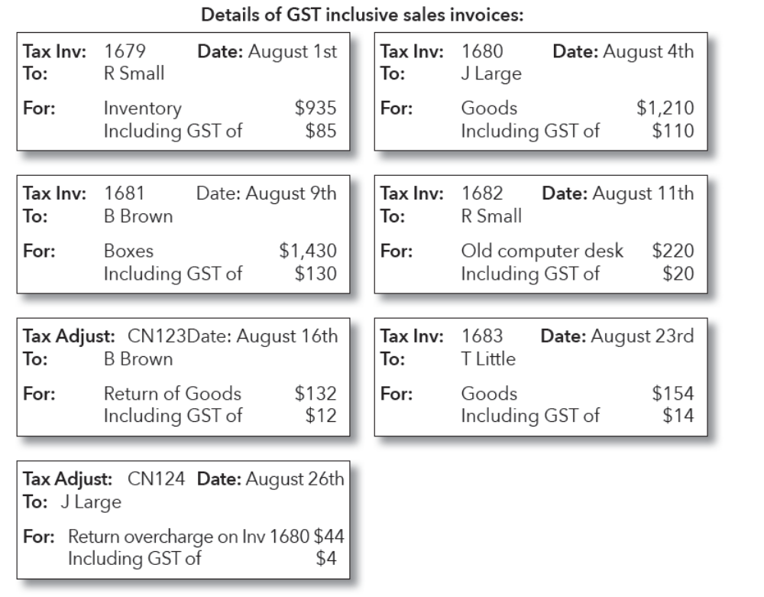
Required:
11a. Enter the above transactions into the Credit Sales Journal. Cross-balance using the column totals.

Credit Sales Journal of ABC Boxes (August) SJ15
 |  |  | Debits | Credits
Date | Invoice # / Adjustment Note # | Particulars | Account Receivable | Sales | Asset | GST  Collected
 |  | Total

11b. Refer to the invoices above. ABC Boxes received a payment from B Brown and issued the following payment receipt.
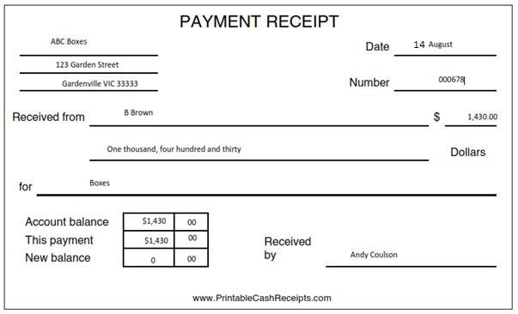
The funds were banked and the following journal entry was recorded in the Cash Receipts Journal.
Dr Bank $1,340.00
Cr Debtors $1,340.00
Required:
Check the invoice for B Brown and the cash receipt given to B Brown.
(Hint: Have the amounts in the Cash Receipts Journal been recorded correctly?)
Record the adjustment needed in the Cash Receipts Journal to correct the error?
Cash Receipts Journal
Date | Receipt No. | Details | A/C  No. | Sales | Debtors | GST Collected | Amount Banked
 |  |  | N/A

12. McGuire Corp made the following Credit Purchases and Returns during April.
All amounts include GST, and McGuire Corp uses a periodic inventory system.

Date | Tax Invoice/Tax Adjustment | Details | Amount (inc. GST)
April 02 | A1356 | Received invoice from B Brown for inventory purchases | $1,100
06 | B 9686 | Bought goods on credit from Ruby Rose | 770
13 | 8923 | Purchased office equip. on credit from Equipwerx | 1,320
18 | A1421 | Bought trade goods from B Brown | 671
21 | C00134 | Received tax adjustment note from B Brown for overcharge on invoice A1356 | 33
26 | B9888 | Received a tax invoice for stock from Ruby Rose | 1,100
30 | 060509 | Purchased goods from Pretty in Pink | 550

Required: Enter the transactions into the Credit Purchases Journal.

Credit Purchases Journal of McGuire Corp (April) PJ17
 |  |  | Accounts to be Debited |  |  | Accounts to be Credited
Date | Invoice/  Adjustment Note # | Particulars | Purchases/  Inventory | Asset | GST Paid | Accounts Payable
 |  | Total

The following questions are based on the material in Chapter 11:
13. From the following information for A. Liu prepare for May 31:
(a) Cash Balance Summary for May and Bank Ledger Account for May
(b) Bank reconciliation statement. Tip: Follow the steps in the bank reconciliation process per chapter 11.5.

The reconciliation on April 30 showed that the Bank Ledger Account had a credit balance (overdraft) of $3,182.90.

The Bank Statement had reconciled to the Bank Ledger Account after allowing for:
• An outstanding deposit $733.10, and
• Unpresented cheque #324856 for $934.02
For May:
Extract Cash Receipts Book of A. Liu |  | Extract Cash Payments Book of A. Liu
02/05 | $ 1,446.52 | 01/05 | 324875 | $ 1,526.16
07/05 | 3,486.72 | 04/05 | 324876 | 905.70
11/05 | 1,538.90 | 08/05 | 324877 | 2,404.38
11/05 | 436.84 | 12/05 | 324878 | 1,702.86
12/05 | 2,360.20 | 15/05 | 324879 | 1,296.98
21/05 | 1,039.30 | 20/05 | 324880 | 561.40
30/05 | 846.76 | 28/05 | 324881 | 1,958.30

The Best Bank Ltd
Bank Statement for A. Liu
Date | Particulars | Debit | Credit | Balance
 | Brought forward |  |  | $ 2,981.98 Dr
01/05 | Cheque #324875 | $ 1,526.16 |  | 4,508.14 Dr
 | Cash/cheques deposit |  | $ 733.10 | 3,775.04 Dr
02/05 | Cash/cheques deposit |  | 1,446.52 | 2,328.52 Dr
05/05 | Cheque #324856 | 934.02 |  | 3,262.54 Dr
07/05 | Cash/cheques deposit |  | 3,486.72 | 224.18 Cr
11/05 | Cash/cheques deposit |  | 1,538.90 | 1,763.08 Cr
12/05 | Cheque #324877 | 2,404.38 |  | 641.30 Dr
 | Cash/cheques deposit |  | 436.84 | 204.46 Dr
15/05 | Cheque book fee | 50.00 |  | 254.46 Dr
17/05 | Cheque #324879 | 1,296.98 |  | 1,551.44 Dr
18/05 | Cash/cheques deposit |  | 2,360.20 | 808.76 Cr
21/05 | Cheque #324878 | 1,702.86 |  | 894.10 Dr
24/05 | L. Mami cheque dishonour | 551.56 |  | 1,445.66 Dr
 | Dishonour fee | 15.00 |  | 1,460.66 Dr
25/05 | Cheque # 324876 | 905.70 |  | 2,366.36 Dr
26/05 | Cash/cheques deposit |  | 1,039.30 | 1,327.06 Dr
31/05 | Cheque #324880 | 561.40 |  | 1,888.46 Dr

(a) Cash Balance Summary for A. Liu as at 31 May
Cash Receipts |  |  | Cash Payments
Date | Details | Amount $ | Date | Details | Amount $
 | Total |  |  | Total

Bank Ledger Account May – specify if Balance is DR or CR.
Bank 100
Date | Details | Folio | Debit | Credit | Balance
1/5 | Balance b/d | N/A |  |  | $3,182.90 CR
31/5 | Receipts | N/A
31/5 | Payments | N/A

(b) Tip: If any, be certain to list any Unpresented Cheques or Outstanding Deposits in this Bank Reconciliation.
Bank Reconciliation Statement as at May 31
 | Cheque No. | $
Debit balance as per Bank Statement |  | $
Add: Unpresented Cheques |  | $
 |  | $
Sub-total |  | $
Less: Outstanding Deposits |  | $
Credit Balance per the Bank Ledger Account |  | $

(c) Provide 3 examples that would give rise to a difference between a bank statement and the bank ledger account of a business.

The following questions are based on the material in Chapter 12:
14. Joshua Owen commenced business on 1 September, and had several special transactions during the month:

Date | Transactions
Sept 01 | Owen contributed the following to the business: Premises $85,000, Cash $4,000,  Mortgage on Premises $30,000 and Shop Fittings $3,000.
Sept 09 | Owen gave the business a Motor Vehicle valued at $5,000 to be used for delivering goods to customers.
Sept 11 | Stock costing $80 plus $8 GST was taken by Owen’s children.
Sept 14 | Surplus shelving, valued at $50 plus $5 GST, was taken by Owen for storing tools in his home garage.

Required: General Journal entries to record these transactions.

General Journal – Joshua Owen GJ1
Date | Particulars | Folio | Debit | Credit
 |  | N/A
 |  | N/A
 |  | N/A
 |  | N/A
 |  | N/A
 | Assets and liability contributed by owner at  commencement of business | N/A
 |  | N/A
 |  | N/A
 | Contribution of motor vehicle by the owner | N/A
 |  | N/A
 |  | N/A
 |  | N/A
 | Drawings of inventory by the owner for personal  use | N/A
 |  | N/A
 |  | N/A
 |  | N/A
 | Shop shelving taken by owner | N/A

The following questions are based on the material in Chapter 13:
15. Please find below a Trial Balance from the ledger of E. Norman, as well as Income Statement and Balance Sheet templates per its policies and procedures:
Required: (a) Complete the worksheet.
  - Prepare an Income Statement for year ended 30 June.
  - Prepare a Balance Sheet at 30 June.
  - Identify features of interim reports.

(a)

WORKSHEET | Trial Balance |  | Income Statement |  | Balance Sheet
Accounts | Debit | Credit | Debit | Credit | Debit | Credit
Building | 31,483
Bank | 1,900
Accounts Receivable | 3,700
Accounts Payable |  | 5,000
GST Collected |  | 2,600
GST Paid | 2,000
Sales |  | 44,593
Cost of Goods Sold | 21,118
Office Equipment | 950
Inventory | 13,832
Delivery Expenses | 475
Insurance | 228
Electricity | 532
Telephone | 190
Salaries | 2,470
Rates | 238
Discount Allowed | 1,007
Rent | 484
Commission Income |  | 807
Capital (opening) |  | 27,607
Net Profit
Totals | 80,607 | 80,607

(b) E. Norman - Income Statement for the year ended 30 June
 | $ | $
Sales |  | $
Less Cost of Goods Sold |  | $
Gross Profit |  | $
Add Other Revenue:
 |  | $
Total Operating Income |  | $
Total Operating Expenses:
 | $
 | $
 | $
 | $
 | $
 | $
 | $
 | $ | $
Net Profit (Loss) |  | $

(c) E. Norman – Balance Sheet as at 30 June
 | $ | $
Current Assets
Bank | $
Accounts Receivable | $
Inventory | $ | $
Non-Current Assets
Building | $
Equipment | $ | $
Total Assets |  | $
Current Liabilities
Accounts Payable | $
GST Payable (GST Collected less GST Paid) | $ | $
Total Liabilities |  | $
Net Assets |  | $
Owners’ Equity
Capital (Opening Bal. 1/7) | $
Net Operating Profit (Loss) | $
 |  | $

- Consider this statement:
‘Interim reports’ are described as ‘interim’ because end of year processes have not yet been completed.
True
or
False

16. The following role play video activities are required to assess your communication skills based on the material covered in this module.
For these activities, you’ll need to:
- Read the activity instructions carefully.
- Find someone to act as the customer and as the Receptionist. These characters can be played by your partner, friend, colleague, etc.
- Record a video file of the role play. If in doubt, look at the tips (on the LMS) for video recording instructions.
- Upload the video file of the role play at the same time as you submit your assignment document.
For the role play, we suggest the following:
- Have a quiet, private space where you can effectively record the video. This could be your spare room at home, an office at your workplace, or even a study room at your local library.
- Be appropriately dressed – like you’re ready for a day on the job!
When you’re conducting the role play, don’t forget about:
- Using appropriate body language and gestures, including eye contact
- Speaking professionally, and at the appropriate pace
- Using plain English
- Listening without interrupting
- Respond appropriately to what is said.

Role Play
Roles:
This role play has three roles:
  - You: bookkeeper
  - Receptionist (at James Bond’s office)
  - James Bond: the customer
Scenario:
You are processing financial transactions to prepare reports for your client. You notice an overdue sales invoice issued to a customer, James Bond.
Organisational process dictates you must attempt to recover the debt before writing it off.
James Bond is a regular customer and has an overdue invoice from February for the amount of $1,650.
You need to ring or meet with the customer and find out why he is late in paying and when this amount will be paid.
The receptionist at James’ office answers your call. You request to speak with James. The receptionist transfers your call to James.
During your conversation with James, he states that he thinks the invoice was already paid.
However, because he is uncertain, he provides you with his credit card details and agrees to allow you to take the payment if the amount was not in fact paid.
You obtain his credit card details and his authorisation to process the credit card payment.
You promise to refer the matter to the Senior Accountant to be checked.
Required Task:
You will need to find a friend to role play James Bond.
You will need to video record the role play and upload the file to the LMS.
Conduct a brief telephone call with James Bond.
You must obtain his credit card details and seek his authorisation to process the credit card payment.
You will be assessed on the following:
- You must first speak with the Receptionist
- You must ask at least two questions of James about the invoice in question.
- You must seek James’ authorisation for processing the credit card transaction.
- You must tell James that the matter will be referred to the Senior Accountant.
Note: Your video recording should only be a couple of minutes in length.

